**Name:** Airware Dorne

**Description:** Founded in 2011 by Jonathan Downey, the son of two pilots, Airware first built an autopilot system for programming drones to follow certain routes to collect data

**Created On:** 31-Jan-22 12:01:23 AM

**Created By:** HEIDER

**Modified On:** 25-Feb-22 7:11:23 AM

**Modified By:** HEIDER

**Size:** 860 KB

¶1: Airware

|  |
| --- |
| ¶2: **Airware, Inc.** |
| ¶3: |

|  |  |
| --- | --- |
| ¶4: **Industry** | ¶5: [UAV](https://en.wikipedia.org/wiki/Unmanned_aerial_vehicle) Systems |
| ¶6: **Founded** | ¶7: 2011 |
| ¶8: **Headquarters** | ¶9: [San Francisco, California](https://en.wikipedia.org/wiki/San_Francisco,_California) |
| ¶10: **Key people** | ¶11: Jonathan Downey (Founder) Yvonne Wassenaar (CEO) |
| ¶12: **Website** | ¶13: [Airware.com](http://www.airware.com/) |

¶14: **Airware** (incorporated as **Unmanned Innovation, Inc.**) was an American venture-funded startup that provided commercial [unmanned aerial vehicles](https://en.wikipedia.org/wiki/Unmanned_aerial_vehicle) for enterprises.[[1]](https://en.wikipedia.org/wiki/Airware#cite_note-1) The company ceased operations on September 14, 2018.[[2]](https://en.wikipedia.org/wiki/Airware#cite_note-airware-shuts-down-2)

¶15: Airware was founded in 2011 in [Newport Beach, California](https://en.wikipedia.org/wiki/Newport_Beach,_California), by [Jonathan Downey](https://en.wikipedia.org/wiki/Jonathan_Downey). The company relocated to [San Francisco](https://en.wikipedia.org/wiki/San_Francisco) in January 2014.[[3]](https://en.wikipedia.org/wiki/Airware#cite_note-OC_Register_Dec_2013-3)

¶16: The company produced enterprise drones which combine hardware, [on-aircraft](https://en.wikipedia.org/wiki/Avionics_software) and mobile software, and [cloud](https://en.wikipedia.org/wiki/Cloud_computing) services. Downey has stated the company is focused on building systems for drones for commercial uses, including anti-poaching efforts, infrastructure inspections, and [precision agriculture](https://en.wikipedia.org/wiki/Precision_agriculture).[[4]](https://en.wikipedia.org/wiki/Airware#cite_note-Rhino_drones-4)

¶17: History

¶18: Airware was founded by Downey in 2011 out of a frustration with the "inflexible and costly" autopilot systems for unmanned aircraft.[[5]](https://en.wikipedia.org/wiki/Airware#cite_note-MIT_35_under_35-5)

¶19: Airware was [incubated](https://en.wikipedia.org/wiki/Business_incubator) at both Lemnos Labs and [Y Combinator](https://en.wikipedia.org/wiki/Y_Combinator_(company)). In March 2016, the company announced a $30 million Series C round of financing led by Next World Capital with Andreessen Horowitz, Kleiner Perkins Caufield & Byers and [Cisco Systems](https://en.wikipedia.org/wiki/Cisco_Systems) executive chairman [John T. Chambers](https://en.wikipedia.org/wiki/John_T._Chambers).[[6]](https://en.wikipedia.org/wiki/Airware#cite_note-Chambers-6) Andreessen Horowitz partner [Martin Casado](https://en.wikipedia.org/wiki/Martin_Casado), Kleiner Perkins Caufield & Byers partner [Mike Abbott](https://en.wikipedia.org/wiki/Mike_Abbott), and John T. Chambers are members of the company's board.[[7]](https://en.wikipedia.org/wiki/Airware#cite_note-Ryan_Enterprise-7) In 2015, Airware launched a new venture fund for commercial drones to support "scaling the use of drones across a variety of commercial applications."[[8]](https://en.wikipedia.org/wiki/Airware#cite_note-8)[[9]](https://en.wikipedia.org/wiki/Airware#cite_note-9) Airware purchased Redbird, a drone analytics software company, in 2016.[[10]](https://en.wikipedia.org/wiki/Airware#cite_note-10) On September 14, 2018, Airware announced it was ceasing operations effective immediately.[[2]](https://en.wikipedia.org/wiki/Airware#cite_note-airware-shuts-down-2)

¶20: Products and services

¶21: Airware offered [enterprise](https://en.wikipedia.org/wiki/Enterprise_architecture) drone services combining hardware, on-aircraft and mobile software, and cloud services for industries like mining, insurance, and construction.[[11]](https://en.wikipedia.org/wiki/Airware#cite_note-11) Airware offered navigation software for drones, table software to guide and monitors drones in flight, and cloud services to store and manage the information gathered by drones.[[12]](https://en.wikipedia.org/wiki/Airware#cite_note-12) Where most software is designed for specific models of drones, Airware was developing a platform that enables compatibility across aircraft.[[13]](https://en.wikipedia.org/wiki/Airware#cite_note-13) The company previously collaborated with commercial drone manufacturers to integrate its autopilot hardware and software, then consulted directly with enterprise clients to identify solutions and to ensure regulatory compliance.[[7]](https://en.wikipedia.org/wiki/Airware#cite_note-Ryan_Enterprise-7)[[14]](https://en.wikipedia.org/wiki/Airware#cite_note-14)[[15]](https://en.wikipedia.org/wiki/Airware#cite_note-15)

¶22: References

* 1. ¶23: **[^](https://en.wikipedia.org/wiki/Airware#cite_ref-1)** *["Company"](http://www.airware.com/about-us). Airware Inc. Retrieved 2013-05-30.*
  2. ¶24: ^ [Jump up to:](https://en.wikipedia.org/wiki/Airware#cite_ref-airware-shuts-down_2-0)***[a](https://en.wikipedia.org/wiki/Airware#cite_ref-airware-shuts-down_2-0)*** ***[b](https://en.wikipedia.org/wiki/Airware#cite_ref-airware-shuts-down_2-1)*** *Constine, Josh (2018-09-14). ["Drone startup Airware crashes, will shut down after burning $118M"](https://techcrunch.com/2018/09/14/airware-shuts-down/). [TechCrunch](https://en.wikipedia.org/wiki/TechCrunch).*
  3. ¶25: **[^](https://en.wikipedia.org/wiki/Airware#cite_ref-OC_Register_Dec_2013_3-0)** *Sablan, Kevin (22 December 2013). ["O.C. drone company moving to Bay Area"](http://www.ocregister.com/articles/company-594519-energy-beach.html). [Orange County Register](https://en.wikipedia.org/wiki/Orange_County_Register). Retrieved 2 April 2014.*
  4. ¶26: **[^](https://en.wikipedia.org/wiki/Airware#cite_ref-Rhino_drones_4-0)** *["Rhino-Saving Drones Give Surveillance a Kinder Look"](https://web.archive.org/web/20170314154737/https:/sg.news.yahoo.com/video/using-drones-assist-search-rescue-231658713.html). [Bloomberg Businessweek](https://en.wikipedia.org/wiki/Bloomberg_Businessweek). 2013-06-28. Archived from [the original](https://sg.news.yahoo.com/video/using-drones-assist-search-rescue-231658713.html) on 2017-03-14.*
  5. ¶27: **[^](https://en.wikipedia.org/wiki/Airware#cite_ref-MIT_35_under_35_5-0)** *Simonite, Tom (2016). ["Innovators Under 35: Jonathan Downey"](https://www.technologyreview.com/lists/innovators-under-35/2016/visionary/jonathan-downey/). [MIT Technology Review](https://en.wikipedia.org/wiki/MIT_Technology_Review).*
  6. ¶28: **[^](https://en.wikipedia.org/wiki/Airware#cite_ref-Chambers_6-0)** *Vanian, Jonathan (2016-03-31). ["Cisco's John Chambers Just Invested In A Hot Drone Startup"](http://fortune.com/2016/03/31/ciscos-john-chambers-airware/). [Fortune](https://en.wikipedia.org/wiki/Fortune_(magazine)).*
  7. ¶29: ^ [Jump up to:](https://en.wikipedia.org/wiki/Airware#cite_ref-Ryan_Enterprise_7-0)***[a](https://en.wikipedia.org/wiki/Airware#cite_ref-Ryan_Enterprise_7-0)*** ***[b](https://en.wikipedia.org/wiki/Airware#cite_ref-Ryan_Enterprise_7-1)*** *Mac, Ryan (2016-03-31). ["Drone Startup Airware Raises $30 Million, Adds Cisco's John Chambers To Board"](https://www.forbes.com/sites/ryanmac/2016/03/31/drone-startup-airware-makes-larger-enterprise-push-adds-former-cisco-ceo-to-board/#649ec235aac4). [Forbes](https://en.wikipedia.org/wiki/Forbes).*
  8. ¶30: **[^](https://en.wikipedia.org/wiki/Airware#cite_ref-8)** *Terdiman, Daniel (2015-05-27). ["Drone OS Developer Airware Launches New Fund For Commercial Drones"](https://www.fastcompany.com/3046758/drone-os-developer-airware-launches-new-fund-for-commercial-drones). [Fast Company](https://en.wikipedia.org/wiki/Fast_Company_(magazine)).*
  9. ¶31: **[^](https://en.wikipedia.org/wiki/Airware#cite_ref-9)** *Constine, Josh (2015-05-27). ["Airware And DJI/Accel Launch Drone Investment Funds"](https://techcrunch.com/2015/05/27/drone-fund/). [TechCrunch](https://en.wikipedia.org/wiki/TechCrunch).*
  10. ¶32: **[^](https://en.wikipedia.org/wiki/Airware#cite_ref-10)** *Haggin, Patience (2016-09-22). ["Commercial Drone Startup Airware Buys Drone Analytics Software Redbrid"](https://www.wsj.com/articles/commercial-drone-startup-airware-buys-drone-analytics-software-redbird-1474527660). [The Wall Street Journal](https://en.wikipedia.org/wiki/The_Wall_Street_Journal).*
  11. ¶33: **[^](https://en.wikipedia.org/wiki/Airware#cite_ref-11)** *["Forty Under 40: Jonathan Downey, Airware"](http://www.bizjournals.com/sanfrancisco/news/2017/03/09/young-leaders-40-under-jonathan-downey-airware.html). [San Francisco Business Times](https://en.wikipedia.org/wiki/San_Francisco_Business_Times). 2017-03-09.*
  12. ¶34: **[^](https://en.wikipedia.org/wiki/Airware#cite_ref-12)** *Jansen, Bart (2015-12-15). ["Airware CEO is Small Business Innovator of the year"](https://www.usatoday.com/story/money/2015/12/15/airware-ceo-small-business-innovator-year/77309546/). [USA Today](https://en.wikipedia.org/wiki/USA_Today).*
  13. ¶35: **[^](https://en.wikipedia.org/wiki/Airware#cite_ref-13)** *Jansen, Bart (2015-07-27). ["Airware Navigates future of drones"](https://www.usatoday.com/story/money/2015/07/23/airware-entrepreneur-downey-auvsi-lemnos/26125045/). [USA Today](https://en.wikipedia.org/wiki/USA_Today).*
  14. ¶36: **[^](https://en.wikipedia.org/wiki/Airware#cite_ref-14)** *Haggin, Patience (2016-10-24). ["Drone Startups Pivoting to Enterprise Services"](https://www.wsj.com/articles/drone-startups-pivoting-to-enterprise-services-1477395001). [The Wall Street Journal](https://en.wikipedia.org/wiki/The_Wall_Street_Journal).*
  15. ¶37: **[^](https://en.wikipedia.org/wiki/Airware#cite_ref-15)** *Haggin, Patience (2016-03-31). ["Airware Takes Off With $30 Million for Commercial Drone Operating System"](https://blogs.wsj.com/venturecapital/2016/03/31/airware-takes-off-with-30-million-for-commercial-drone-operating-system/). [The Wall Street Journal](https://en.wikipedia.org/wiki/The_Wall_Street_Journal).*

¶38: Further reading[[edit](https://en.wikipedia.org/w/index.php?title=Airware&action=edit&section=4)]

* ¶39: *Gallagher, Sean (August 14, 2013). ["Raspberry Fly? Airware's Linux and ARM developer platform for drones"](https://arstechnica.com/information-technology/2013/08/raspberry-fly-airwares-linux-and-arm-developer-platform-for-drones/). [Ars Technica](https://en.wikipedia.org/wiki/Ars_Technica). Retrieved February 9, 2017.*
* ¶40: *Russon, Mary-Ann (September 12, 2014). ["Drone Operating System: MIT Startup Airware and Nasa Transforming Hobby into Commercial Industry"](http://www.ibtimes.co.uk/drone-operating-system-mit-startup-airware-nasa-transforming-hobby-into-commercial-industry-1465251). [International Business Times](https://en.wikipedia.org/wiki/International_Business_Times). Retrieved February 9, 2017.*
* ¶41: *["Drones CAN'T deliver goods ... oh. Air traffic control system backed by NASA, you say?"](https://www.theregister.co.uk/2014/09/16/drone_city_air_traffic_control_system/). [The Register](https://en.wikipedia.org/wiki/The_Register). September 16, 2014. Retrieved February 9, 2017.*
* ¶42: ["Why Is America Losing the Commercial Drone Wars?"](http://washingtonmonthly.com/magazine/junejulyaug-2015/why-is-america-losing-the-commercial-drone-wars/). June/July/August 2015. *[Washington Monthly](https://en.wikipedia.org/wiki/Washington_Monthly)*.
* ¶43: *["Airware Launches Drone Operating System And Picks Up Intel As An Investor"](https://www.forbes.com/sites/gregorymcneal/2015/04/16/intel-invests-in-startup-airware-as-the-company-releases-an-operating-system-for-drones/#79a7b446316c). [Forbes.com](https://en.wikipedia.org/wiki/Forbes.com). April 16, 2015. Retrieved June 8, 2017.*
* ¶44: *Intelligence, BI (September 23, 2016). ["Airware acquires drone-powered analytics company"](http://www.businessinsider.com/airware-acquires-drone-powered-analytics-company-2016-9). [Business Insider](https://en.wikipedia.org/wiki/Business_Insider). Retrieved June 8, 2017.*
* ¶45: ["Caterpillar invests in Airware bringing drone tech to mining and construction enterprises"](https://techcrunch.com/2017/02/02/caterpillar-invests-in-airware-bringing-drone-tech-to-mining-and-construction-enterprises/). February 2, 2017. [TechCrunch](https://en.wikipedia.org/wiki/TechCrunch).
* ¶46: *Benton, Dale (March 17, 2017). ["Reach for the sky: Airware and the future of drones in the mining industry"](http://www.miningglobal.com/technology/reach-sky-airware-and-future-drones-mining-industry). Mining Global. Retrieved June 8, 2017.*

¶47: External links[[edit](https://en.wikipedia.org/w/index.php?title=Airware&action=edit&section=5)]

* ¶48: [Official website](http://www.airware.com/)

¶49:

**¶50: Airware Drone startup Airware crashes, shuts down after burning $118M**

¶51: **[Josh Constine](https://techcrunch.com/author/josh-constine/)**[@joshconstine](https://twitter.com/joshconstine) / 8:22 PM GMT+2•September 14, 2018

¶52:  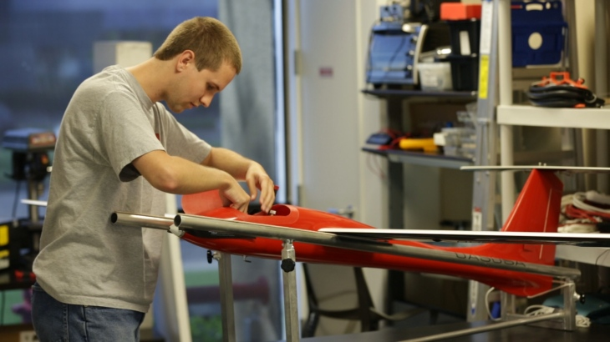

¶53: Drone operating system startup Airware today suddenly informed employees it will cease operations immediately despite having raised [$118 million](https://www.crunchbase.com/organization/airware#section-overview) from top investors like Andreessen Horowitz, Google’s GV, and Kleiner Perkins. The startup ran out of money after trying to manufacture its own hardware that couldn’t compete with drone giants like China’s DJI. The company at one point had as many as 140 employees, all of which are now out of a job.

¶54: A source sent TechCrunch screenshots from the Airware alumni Slack channel detailing how the staff was told this morning that Airware would shut down.

¶55: Airware makes a cloud sofware system that helps enterprise customers like construction companies, mining operations, and insurance companies reviewing equipment for damages to use drones to collect and analyze aerial data. That allowed companies to avoid using expensive helicopters or dangerous rigs with humans on harnesses to make inspections and gauge work progress.

¶56: 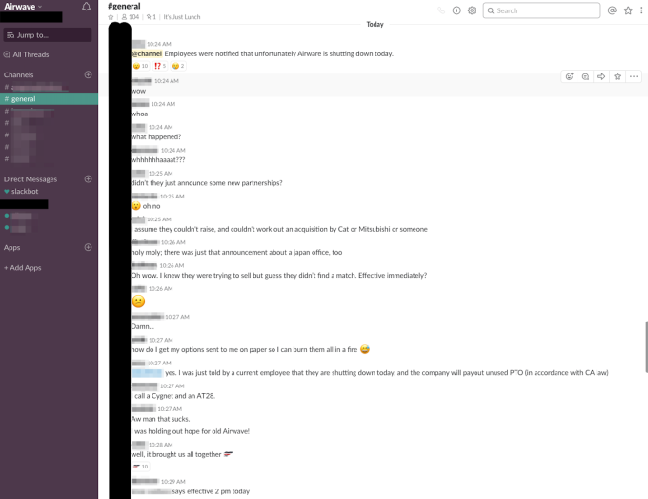

¶57: One ex-employee asked “How do I get my options sent to me on paper so I can burn them all in a fire?”

¶58: Founded in 2011 by Jonathan Downey, the son of two pilots,[Airware first built an autopilot system for programming drones](https://techcrunch.com/2015/04/16/airware/) to follow certain routes to collect data. It could help businesses check rooftops for damage, see how much of a raw material was coming out of a mine, or build constantly-updated maps of construction sites. Later it tried to build its own drones before pivoting to consult clients on how to most efficiently apply unmanned aerial vehicles.

¶59: 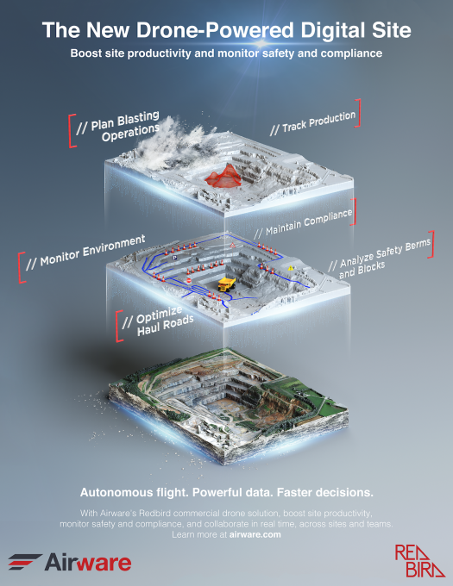While flying high, Airware launched its own [Commercial Drone Fund](https://techcrunch.com/2015/05/27/drone-fund/) for investing in the market in 2015, and [acquired 38-person drone analytics startup Redbird](https://techcrunch.com/2016/09/22/airware-buys-redbird-to-build-a-full-stack-commercial-drone-services-empire/) in 2016. In this pre-crypto, pre-AI boom, Airware scored a ton of hype from us and others as tried to prove[drones could be more than war machines](https://techcrunch.com/2014/01/13/drones-for-good/). But over time, the software that shipped with commercial drone hardware from other manufacturers was good enough to make Airware irrelevant, and a downward spiral of layoffs began over the past two years, culminating in today’s shutdown. Demonstating how sudden the shut down is, Airware opened a Tokyo headquarters alongside an investment and partnership from Mitsubishi just four days ago.

¶60: “Airware was ahead of the game trying to build their software. So far ahead that**the drone hardware on the market wasn’t sophisticated enough** to actually produce the granularity of data they needed to test out their software/train their algorithms” an ex-employee told TechCrunch (emphasis ours). “**So they spent shitloads of money designing bespoke hardware**, including two drones in-house, one multi-rotor called an AT-28, and one fixed-wing called Cygnet. Both projects were scuttled as hardware from DJI and Ebee caught up to needs, after sinking tons of engineering time and manufacturing into them.”

¶61: Following TechCrunch’s inquiry about the unnannounced news, Airware confirmed the shut down to us with this statement:

¶62: “History has taught us how hard it can be to call the timing of a market transition. We have seen this play out first hand in the commercial drone marketplace. We were the pioneers in this market and one of the first to see the power drones could have in the commercial sector. Unfortunately, the market took longer to mature than we expected. As we worked through the various required pivots to position ourselves for long term success, we ran out of financial runway. As a result, it is with a heavy heart that we notified our team, customers, and partners that we will wind down the business.

¶63: This is not the business outcome we had worked so hard for over the years and yet we are deeply proud of our company’s accomplishments and our leadership in driving the adoption of drone powered analytics to improve productivity, mitigate risks, and take workers out of harm’s way.

¶64: As we close the book of Airware; we want to thank the partners and customers who believed in us and helped us along the way. And, while it is difficult to say goodbye to our team, we want to thank them for all they have contributed to Airware and the industry. We look forward to seeing how they will take their learnings from Airware to fuel continued innovations in the world around us.”

¶65: [Update: Since we broke the news, Airware has put up a [“thank you” note](https://www.airware.com/en/thank-you/) about the shutdown informing clients that “A representative from the Airware team will be in touch.”]

¶66: 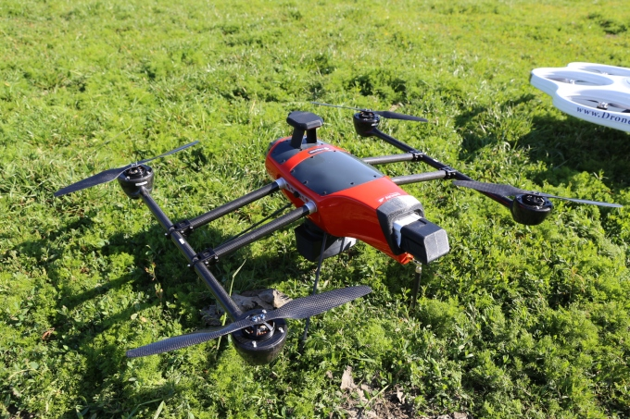

¶67: *An Airware-hardware equipped drone*

¶68: Employees will get one week’s severance, COBRA insurance until November, and payouts for unused paid time off. It appears the startup wasn’t able to raise necessary funding to save the company or secure an acquisition from one of its strategic partners like Catepillar.

¶69: Airware will serve as cautionary tale of startup overspending in hopes of finding product-market fit. Had it been more frugal, saved cash to extend its runway, and given corporate clients more time to figure out how to use drones, Airware might have stayed afloat. Sometimes, even having the most prestigious investors can’t save a startup from mismanagement.

¶70: Our ex-employee source concludes that “I think having $118M in the bank led Airware to charge ahead and sink tons of money into force-it-to-work methods rather than exercise a bit of patience and wait for the inevitable advance of hardware to catch up. They had a knack for hiring extremely talented and expensive people from places like Google, Autodesk, there was even SpaceX and NASA alumni there. They spared no expense ever.”

¶71:

¶72:

¶73:

¶74: Airware

¶75: **Company: Airware**¶76:

¶77: **Select VC investors: Andreessen Horowitz, GE Ventures, Google Ventures, Intel Capital, Kleiner Perkins Caufield & Byers**¶78:

¶79: **Total disclosed funding: $101M**¶80:

¶81: **It appears [Airware] wasn’t able to raise necessary funding to save the company or secure an acquisition from one of its strategic partners like Catepillar.**¶82: ¶83: **Airware will serve as cautionary tale of startup overspending in hopes of finding product-market fit. Had it been more frugal, saved cash to extend its runway, and given corporate clients more time to figure out how to use drones, Airware might have stayed afloat. Sometimes, even having the most prestigious investors can’t save a startup from mismanagement.**

¶84: